Water Treatment Plant
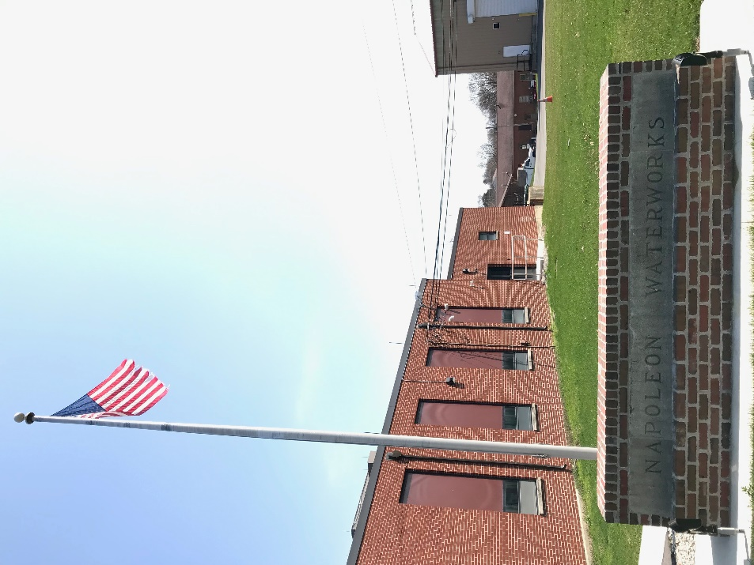
The City of Napoleon Water Treatment Plant underwent a 3-year rehabilitation on the existing Lime-Soda Softening plant starting in 2015 and ending in the fall of 2018. The project went in 3 phases with the end goal being a Reverse Osmosis Membrane Softening Facility. With moving to the Membrane technology, the City of Napoleon is able to keep up with all the current and upcoming regulations set upon us through the Ohio EPA and guarantee the best quality Drinking Water. The Membranes are one of the best treatment options for various problems of high concern in the Drinking Water world including; nitrates, HAB’s, Hardness, and other leading contaminates. Start to finish the entire facility was rehabbed to run consistent with the new style treatment demands.
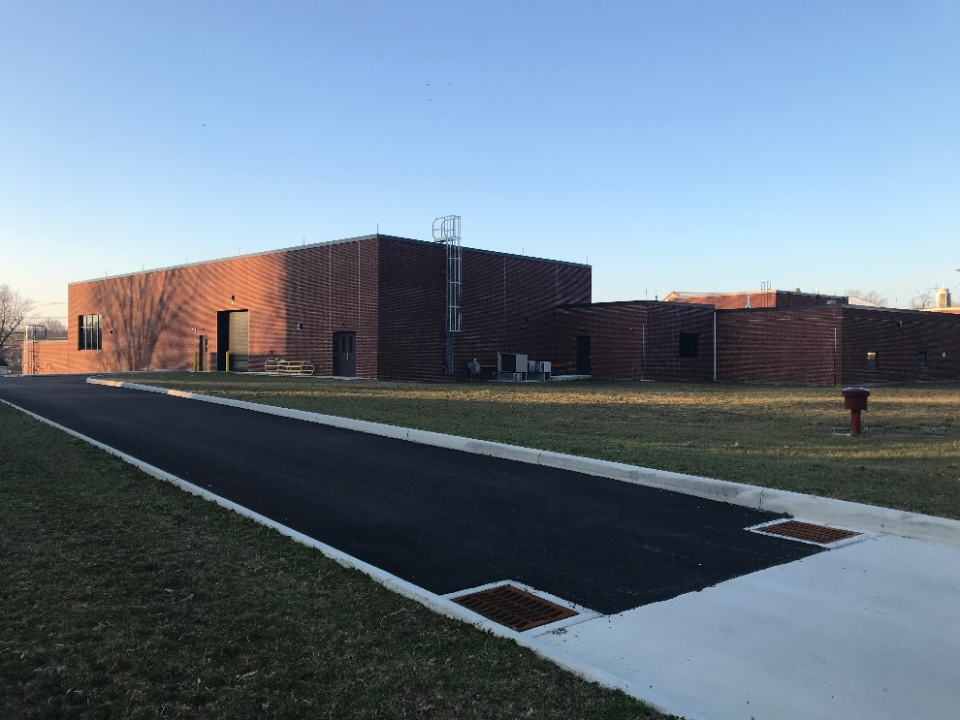
The Raw Water Intake Facility is located along West Riverview across from the Haley St. intersection. This facility was installed in 1992 and is equipped with three low service pumps, two grit screens, backup chemical feed stations, and an emergency standby generator. Two low service pumps are dedicated for supplying water to the water treatment plant, and one low service pump is dedicated to sending water to the City of Wauseon’s reservoir. Every night at shutdown of the water plant, the intake facility remains operating with one low service pump pumping water from the Maumee River and supplying the reservoir. In return, the City of Napoleon can reverse the flow and pull back water from the Wauseon reservoir by gravity in the event the Maumee River water quality is too contaminated to treat.
The plant low service pumps pump raw water into a newly re-purposed Pretreatment Facility. The River water is chemically treated with Sodium Permanganate and Carbon in 2 contact basins. In this building, there is significant contact time with these chemicals the plant did not have before to allow for better removal of contaminants in the Maumee River water. After the contact-time through this facility, the water is dosed with Aluminum Chlorohydrate to coagulate the colloidal solids (dirt, mud) and contaminates as it leaves and enters the existing water plant structure through the existing lines.
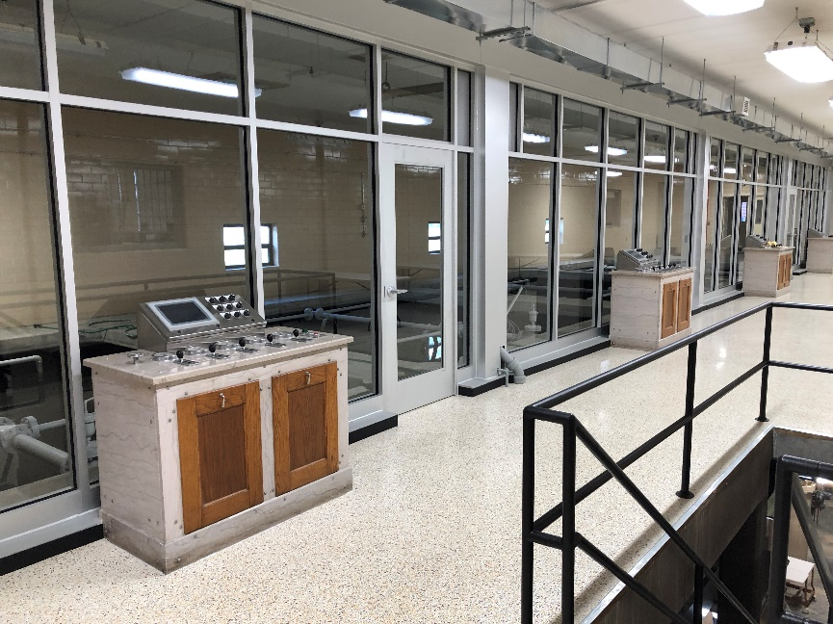
The plant now runs water parallel through 4-stage vertical Flocculation to allow the chemically coagulated water to floc together and form bigger particles to settle out in the Sedimentation Basins. This allows us to achieve better water clarity through this stage of the treatment process than the City has ever seen. After the water settles the dirt and the colloidal solids out of the water, it now flows up through the newly installed Plate Settlers on the backside of the Sedimentation Basins. This allows only the clearest settled water to enter the Basin feeding the Rapid Sand Filters. The Rapid Sand Filters underwent a complete rehab through the winter of 2017 where the Contractors replaced all the filter underdrains to the newest technology and added Sand and Anthracite media to filter out any smaller particles that made it through the sedimentation process.
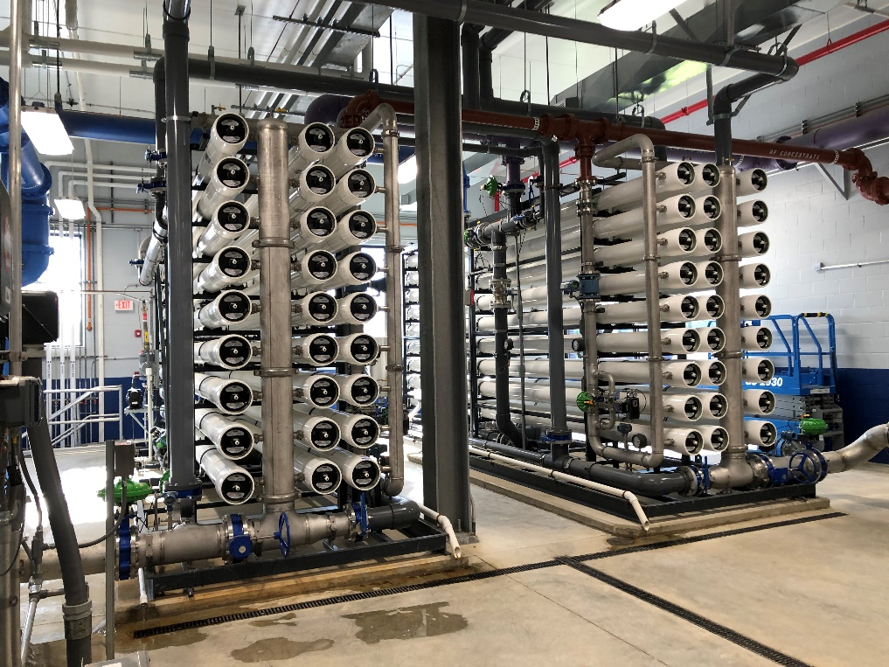
In the old plant, the water leaving the Rapid Sand Filters went through disinfection at this point and straight to the clearwell for distributing to the distribution system. Now, the water leaving the Rapid Sand Filters goes through existing pipework to the new membrane building built through the summer/winter of 2017. This building went online in April of 2018, where the water gets pumped up through 1 micron Cartridge Filters and then through Nano Filtration and Reverse Osmosis filtration. In this building is now where the plant removes calcium and magnesium hardness to soften its water and removes any additional contaminates in the water like Nitrates and TOC. The water leaving these membrane skids is chemically dosed with chlorine, fluoride, caustic soda, and orthophosphate before entering the clearwell for storage. Chlorine helps with disinfection, fluoride helps with teeth and bone growth, caustic soda raises and stabilizes the pH of the water, and Orthophosphate is a corrosion inhibitor required by the EPA.
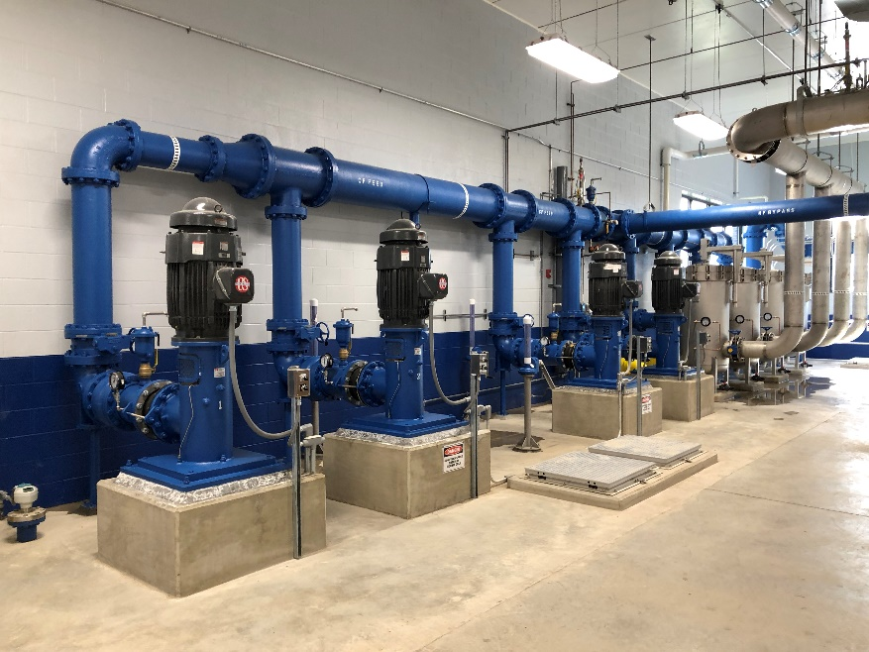
Water is then stored in the 2 separate Clear well’s on site underground. In the membrane construction project there was a second clearwell added for redundancy purposes. The new clearwell holds approximately 150,000 gallons. The second clearwell that was existing holds approximately 1,000,000 gallons. When the distribution system calls for water due to the 2 water tower levels getting low, one of the 3 new High service pumps installed in fall of 2016 will turn on to supply water to the distribution system from the underground clearwell storage. Before the water leaves the Water Treatment plant and enters the system it will go through one of the two Ultraviolet (UV) Reactors. This treatment tool helps meet the LT2 rule for Cryptosporidium that the City of Napoleon triggered with positive tests for E-Coli and Cryptosporidium in the Maumee River. The high service pump will run automatically to fill the water towers to a set height set by the operators and then cycle on and off as needed. The North Water tower that is located on Vocke St. holds approximately 750,000 gallons of treated water. The South Water Tower located on South Perry St. holds approximately 200,000 gallons of treated water. The water towers help supply necessary pressures in the distribution system lines and serve as emergency storage in the event of fires or other unplanned water demands.
Laboratory
The Napoleon Water Plant laboratory has six Operators of the plant that are fully certified in Chemistry and Microbiology by the State of Ohio EPA. These certifications are required to test for Safe drinking water.
Staffing
The City of Napoleon employees 6 full time operators at the Water Treatment plant. One Superintendent and one Assistant Superintendent fill management roles. The operating team consists of one Chief Operator and three Water supply Operators.
Satellite Customers
Outside of the City of Napoleon, the Water system currently provides water to the Village of Florida, Village of Malinta, Northwest Water and Sewer District, and the Village of Liberty Center.

Bulk Water
At the Water Treatment plant, we offer the availability to purchase bulk water to fill up customer provided storage tanks of all sizes. The new bulk water system was installed in 2018 during the rehab construction process and currently is taking new customers. In order to use the bulk water fill station, you will need to fill out a utility form that can be picked up at the Napoleon City offices located at 255 West Riverview Ave. After signing up, you will be given an Access ID and PIN number to use to get bulk water 24/7 at the water treatment plant.
Plant Hours of Operation
Monday – Friday: 5 am to 5 pm
Saturday – Sunday: 7 am to 3 pm
Contact Information
Email: info@napoleonohio.com
Phone: 419-592-8811
Water Treatment Plant Superintendent: Jeffrey L. Weis

